
ADVISOR:
Mr. Waqas Ahmed

Project Monitoring and Control Plan
FARMER PLUS

Version 1.2

TEAM:
Syed Qasim Ifzal
Muhammad Zubair
Amber Shahid
Tahir Rauf
Revision Sheet

Release No. | Date | Revision Description
1.0 | 22/9/2010 | Initial draft of Monitoring and Control Plan
1.1 | 26/9/2010 | Section 1.0 and 4.0 – Updated
1.2 | 30/9/2010 | Final Review conducted

PROJECT MONITORING AND CONTROL PLAN

TABLE OF CONTENTS

1.0 GENERAL INFORMATION 5
1.1 Purpose 5
1.2 Scope 5
1.3 Reference Documents 5
1.4 Acronyms and Abbreviations 5
1.5 Points of contact 6
1.5.1 Information 6
1.5.2 Coordiantion 6
2.0 MONITORING AND CONTROL PROCESS AND ACTIVITIES 8
2.1 Process 8
2.2 Activities and Responsibilities 8
2.2.1 Monitor Project Planning Parameters 9
2.2.2 Monitor Commitments 9
2.2.3 Monitor Project Risk 9
2.2.4 Monitor Data Management 10
2.2.5 Monitor Stakeholder Involvement 10
2.2.6 Conduct Progress Review 10
2.2. 6 Manage Corrective Actions 11
3.0 METRICS 13
4.0 APPENDIX – A 15

- GENERAL INFORMATION

1.0 GENERAL INFORMATION

Although Agriculture Industry is a large part of Pakistan’s economy, not much research has been done in providing up to date information & facilities to the farmers working in this sector in every corner of Pakistan. Therefore, we will develop an SMS (Short Message Service) & IVR (Interactive Voice Response) facility system called “Farmer Plus” that will provide our farmers ready information (e.g. Hourly weather forecast, Weekly weather forecast, Temperature, Precipitation, Humidity etc.) whenever they need it.

1.1 Purpose

The purpose of Project Monitoring and Control is to provide an understanding of the project‘s progress so that appropriate corrective actions can be taken when the project‘s performance deviates significantly from the plan.

1.2 Scope

The scope of the Project Monitoring and Control Plan is limited to all the documents related with the project. The policy is to:
- Track actual results and performances against the software plans.
- Take corrective actions when actual results and performance deviate from the software plans.
- Involve all stakeholder for any changes to software commitments

1.3 Reference Documents

Sr No | Reference No | Document
1 | FM-RFD-001 | AVL Monitoring Plan http://www.itq.ch

1.4 Acronyms and Abbreviations

Sr No | Acronym/Abbreviation | Stands for
1 | CPI | Cost Price Index
2 | SPI | Schedule Price Index
3 | PMC | Project Monitoring and Control
4 | CCB | Change Control Board
5 | FS | Functional Specification
6 | PM | Project Manager
7 | DM | Development Manager
8 | RM | Risk Manager
9 | CM | Configuration Manager
10 | DM | Development Manager
11 | QM | Quality Manager

1.5 Points of contact

1.5.1 Information

Sr No | Resource | Contact
1 | Syed Qasim Ifzal PM | - L080969@lhr.nu.edu.pk  - 0300 4529366
2 | Muhammad Zubair DM | - L080808@lhr.nu.edu.pk  - 0300 4446625
3 | Tahir Rauf CM | - L095068@lhr.nu.edu.pk  - 0333 4388447

1.5.2 Coordiantion

Sr No | Resource | Contact
1 | Amber Shahid RM, QM | - L095061@lhr.nu.edu.pk  - 0300 4912345
2 | Muhammad Zubair DM | - L080808@lhr.nu.edu.pk  - 0300 4446625

2.0 MONITORING AND CONTROL PROCESS AND ACTIVITIES

2.0 MONITORING AND CONTROL PROCESS AND ACTIVITIES

2.1 Process

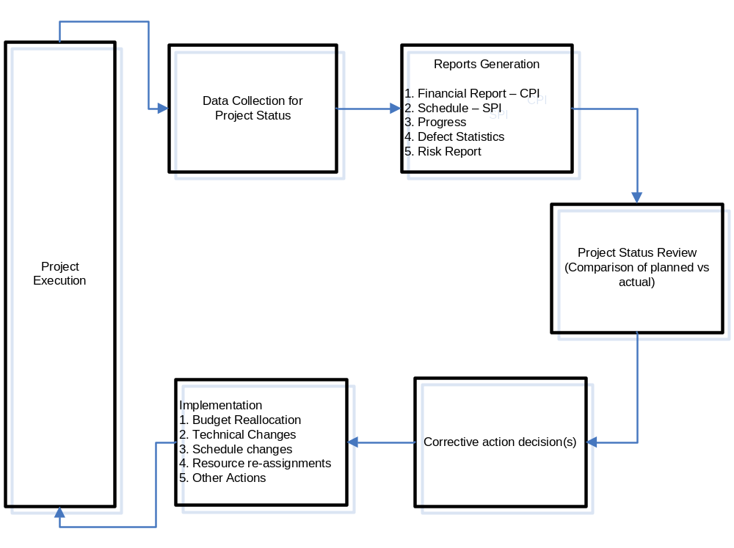
Figure: 1- Monitoring and Control Process

2.2 Activities and Responsibilities
The major Activities performed shall be:
- Monitor Project Planning Parameters
- Monitor Commitments
- Monitor Project Risks
- Monitor Data Management
- Monitor Stakeholder Involvement
- Conduct Progress Reviews
- Manage Corrective Actions

2.2.1 Monitor Project Planning Parameters

Sr No | Sub-activity | Responsibility
1 | Establish and maintain the project summary report | PM, RM
2 | CCB Report Management | CM
3 | Team Meeting | PM
4 | Management Review - Corrective Action Recommendations | All Team members

2.2.2 Monitor Commitments

Sr No | Sub-activity | Responsibility
1 | Commitment Deviation Report | RM
2 | Causal Analysis | RM
3 | Team Meeting | PM
4 | Management Review - Corrective Action Recommendations | All Team members

2.2.3 Monitor Project Risk

Sr No | Sub-activity | Responsibility
1 | Risk Register Update | RM
2 | Impact Analysis Report | CM, RM
3 | Team Meeting | PM
4 | Management Review - Corrective Action Recommendations | All Team members

2.2.4 Monitor Data Management

Sr No | Sub-activity | Responsibility
1 | Data Management Report | DM, CM
2 | Database Backup Accountability | DM
3 | Team Meeting | PM
4 | Management Review - Corrective Action Recommendations | All Team members

2.2.5 Monitor Stakeholder Involvement

Sr No | Sub-activity | Responsibility
1 | Filter Issues Log | QM
2 | Categorize Complaints | RM
3 | Team Meeting | PM
4 | Management Review - Corrective Action Recommendations | All Team members

2.2.6 Conduct Progress Review

Sr No | Sub-activity | Responsibility
1 | Defect Report | PM
2 | Trend Analysis of:  - Financial  - Schedule  - Resource  - Milestones | PM
3 | Team Meeting | PM
4 | Management Review - Corrective Action Recommendations | All Team Members

2.2. 6 Manage Corrective Actions

Sr No | Sub-activity | Responsibility
1 | Corrective Action Recommendations Report | PM
2 | Team Meeting | PM
3 | Management Review - Corrective Action Report and Implementation Intimation | All Team Members

  - METRICS

METRICS
The following metrics shall be used to control and measure the project.
Sr No | Matrix | Parameter Measured
1 | SPI | Schedule deviations
2 | CPI | Cost deviations
3 | Defect Rate Analysis | Monitor defect resolution according to priority
4 | LOC/week | Resource performance

A Sample sheet attached as APPENDIX – A shall be used to record data to be used by monitoring and control plan.

4.0 APPENDIX – A

4.0 APPENDIX – A

Phase/Sub phase | Cost | Effort | Progress | Risk | Schedule

